Control Mapping & Framework Alignment Summary
Pacific Utilities Corporation (PUC)
Prepared by: Bernadette Chan, GRC Analyst
Version 1.0 | August 2026
Frameworks & Standards: NIST CSF 2.0, ISO/IEC 27001:2022, CIS Controls v8, SOC 2 Trust Services Criteria

Summary
This assessment mapped 14 PUC cybersecurity controls across 4 frameworks to evaluate control alignment and identify gaps. The mapping identified 7 controls as Fully Aligned, 6 as Partially Aligned, and 1 Gap Identified, with the identified gap relating to AI Governance.

Key Findings

Framework Alignment
PUC's controls were mapped to 4 frameworks, including applicable categories, controls, safeguards, and criteria, to identify common coverage, areas of partial alignment, and gaps.
NIST CSF 2.0 provides a cybersecurity risk and outcomes framework, ISO/IEC 27001:2022 provides an information security management system and risk management structure, CIS Controls v8 provides prioritized and actionable cybersecurity safeguards, and SOC 2 Trust Services Criteria provide control criteria used for assurance activities.

Control Mapping Matrix

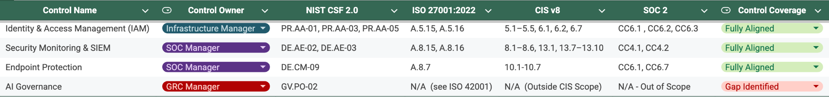
Core technical controls showed strong alignment across areas including multi factor authentication, vulnerability management, incident response, backup and disaster recovery, identity and access management, security monitoring, and endpoint protection. Governance and program management controls showed greater opportunities for improvement, with several assessed as Partially Aligned.
Enterprise Risk Management and AI Governance were assessed according to applicable framework scope, with some frameworks marked as out of scope. AI Governance was the only control assessed as Gap Identified. The mapping provides a baseline for control improvement, compliance activities, and audit readiness.

Next Steps
Controls assessed as Partially Aligned should be reviewed for opportunities to strengthen governance and implementation.
Project 5 will collect evidence for the mapped controls and support PUC's SOC 2 Type II audit conducted by KPMG.

Reference Materials
- NIST Cybersecurity Framework (CSF) 2.0: Cybersecurity Risk Management Framework
- ISO/IEC 27001:2022: Information Security Management Systems — Requirements
- CIS Critical Security Controls v8: Prioritized Cybersecurity Safeguards
- AICPA Trust Services Criteria: Security, Availability, Processing Integrity, Confidentiality, and Privacy

